**HAMZA EJAZ**

**S # B19102041**

**BSCS-III (MORNING)**

**Section-A**

**Database Management**

**System**

**Lab 3a:**

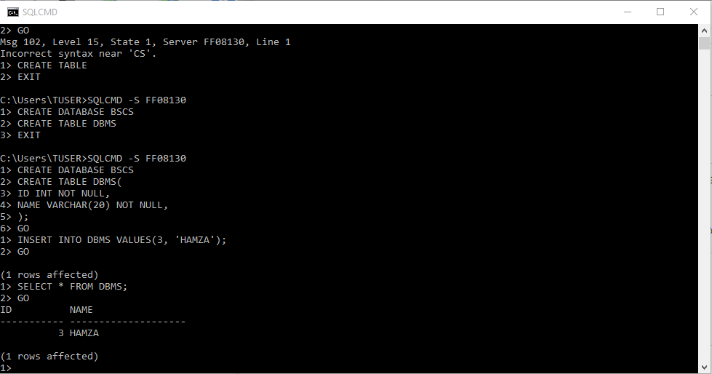

**Lab 3b:**

**using SQL management Studio**

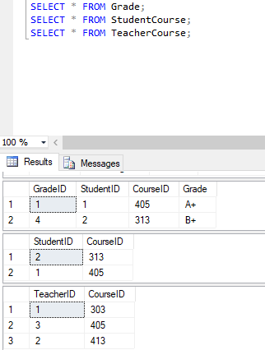

**using SqlCmd utility**

